Metaspace leak:

1. Set VM parameters: 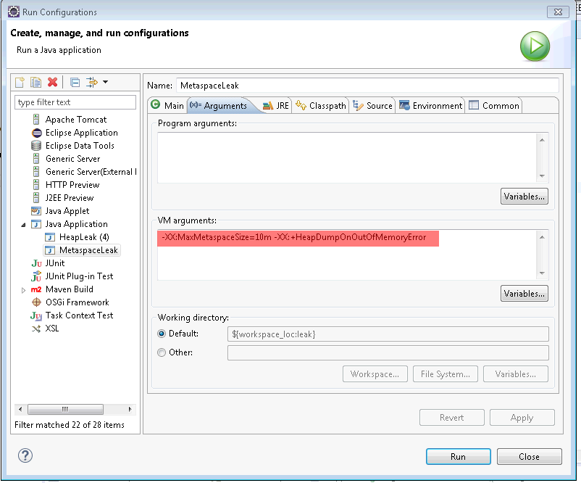
2. Run a MetaspaceLeak class from Task3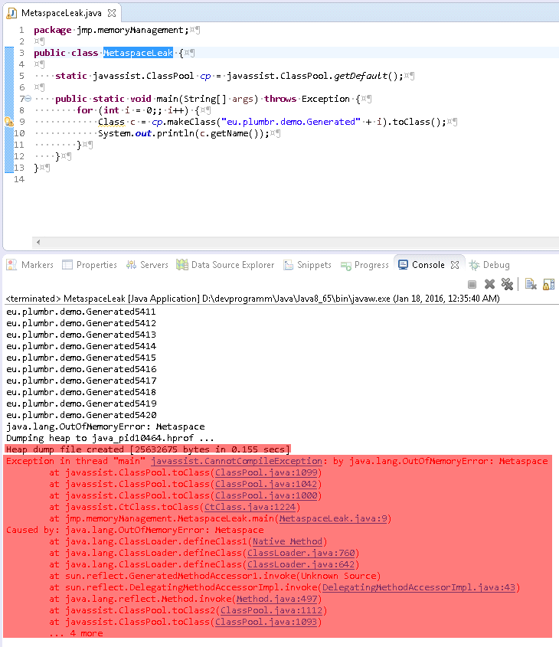
3. Opened the created heap dump with the memory analyzer tool. It showed the “Leak Suspects” info. In this particular case suspicion is correct. But issue not because of size of this object but because of small metaspace memory and a large number of created classes.

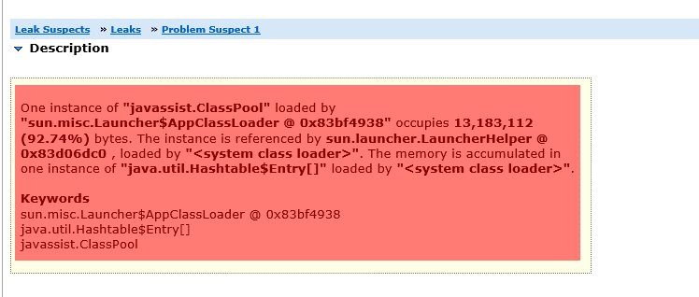

1. See ClassPool details

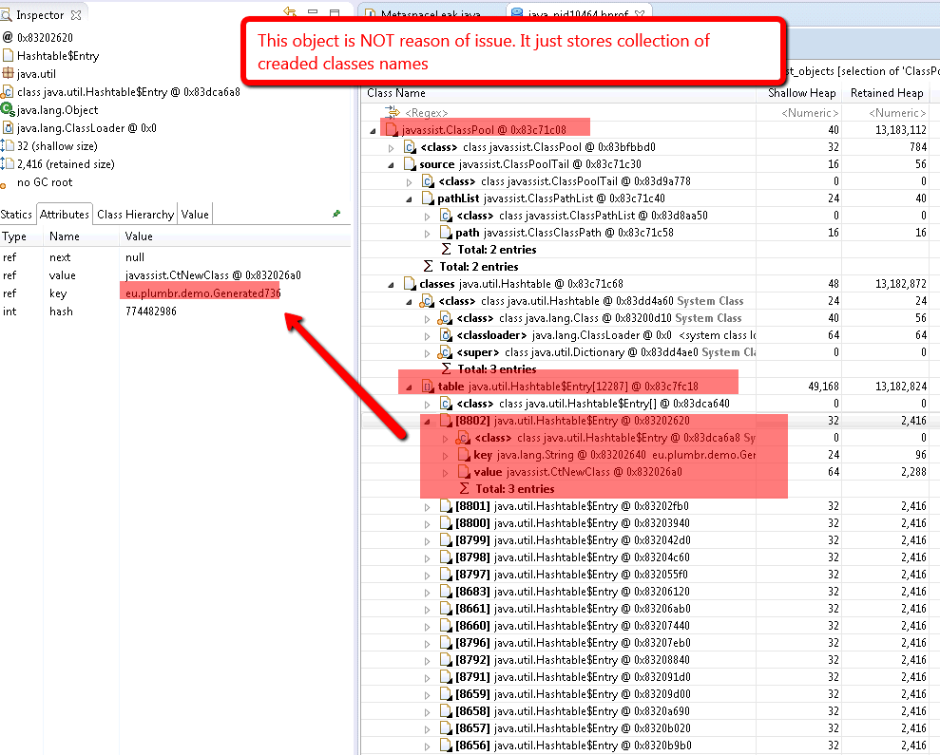

1. The real reason of the issue is a large number of created classes.

